Ex.no:7
DATA VISUALIZATION USING TABLEAU
Aim:
To connect, analyze, visualize, and create an interactive FIFA World Cup 2026 player performance dashboard using Tableau for effective sports data analytics.
Algorithm:
Algorithm: FIFA World Cup 2026 Player Performance Visualization using Tableau
Step 1: Data Loading
- Connect the FIFA World Cup 2026 Player Performance CSV dataset to Tableau.
- Verify the fields player_name, team, position, goals, assists, player_rating, performance_score, tournament_stage, and match_result.
- Check that numerical fields are recognized as measures.
Step 2: Player Goals Bar Chart
- Create a worksheet for player-wise goal analysis.
- Place player_name on Rows and goals on Columns.
- Select the Bar Chart visualization.
- Use SUM(goals) and enable data labels.
Output: Player Goals – Top 10 Players
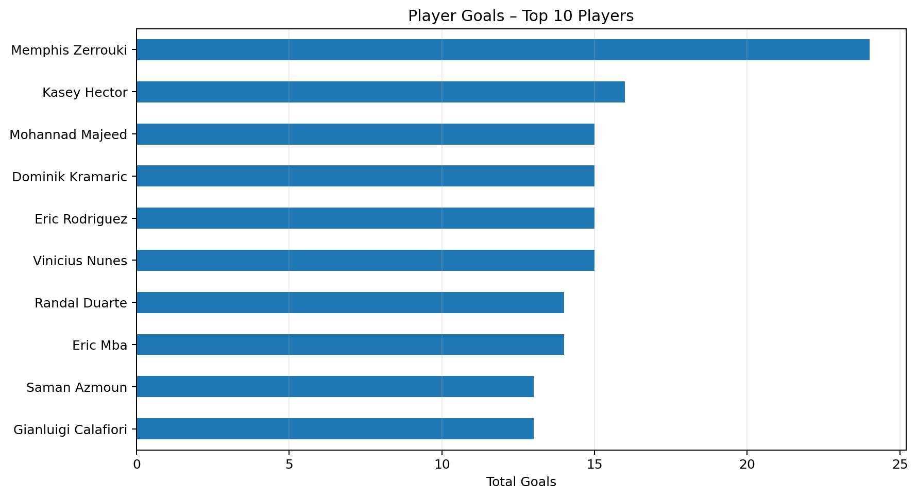
Step 3: Team-wise Goal Contribution
- Create a worksheet using team and goals.
- Aggregate goals using SUM.
- Select a Pie Chart and place team in the color or label area.
- Place SUM(goals) in the angle or size area.
Output: Team Goal Contribution
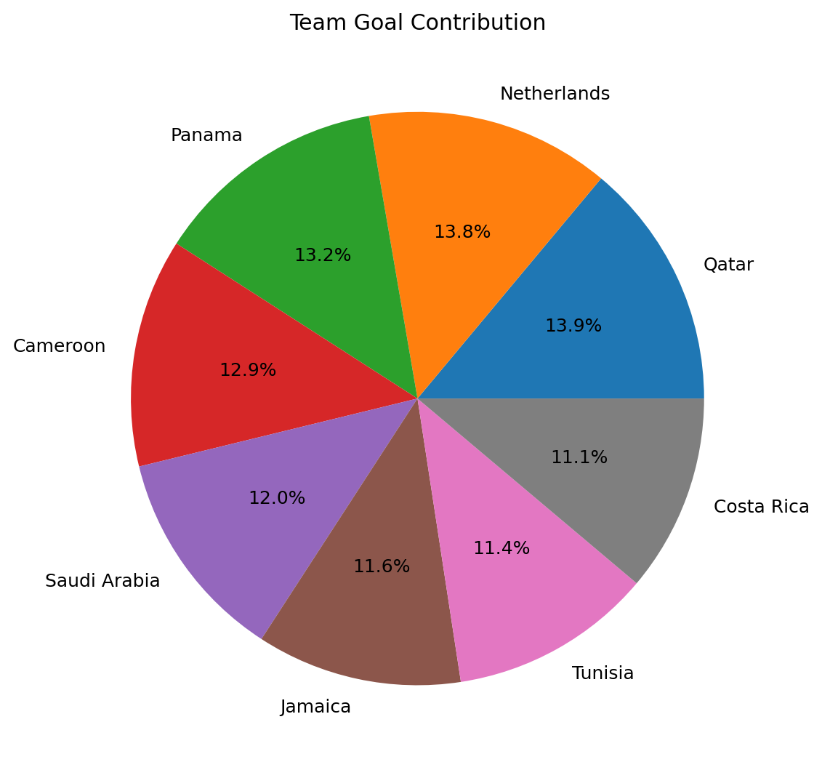
Step 4: Player Performance Trend
- Create a Line Chart using player_name and player_rating.
- Place player_name on Columns and AVG(player_rating) on Rows.
- Enable labels and compare the average ratings.
Output: Player Performance Trend
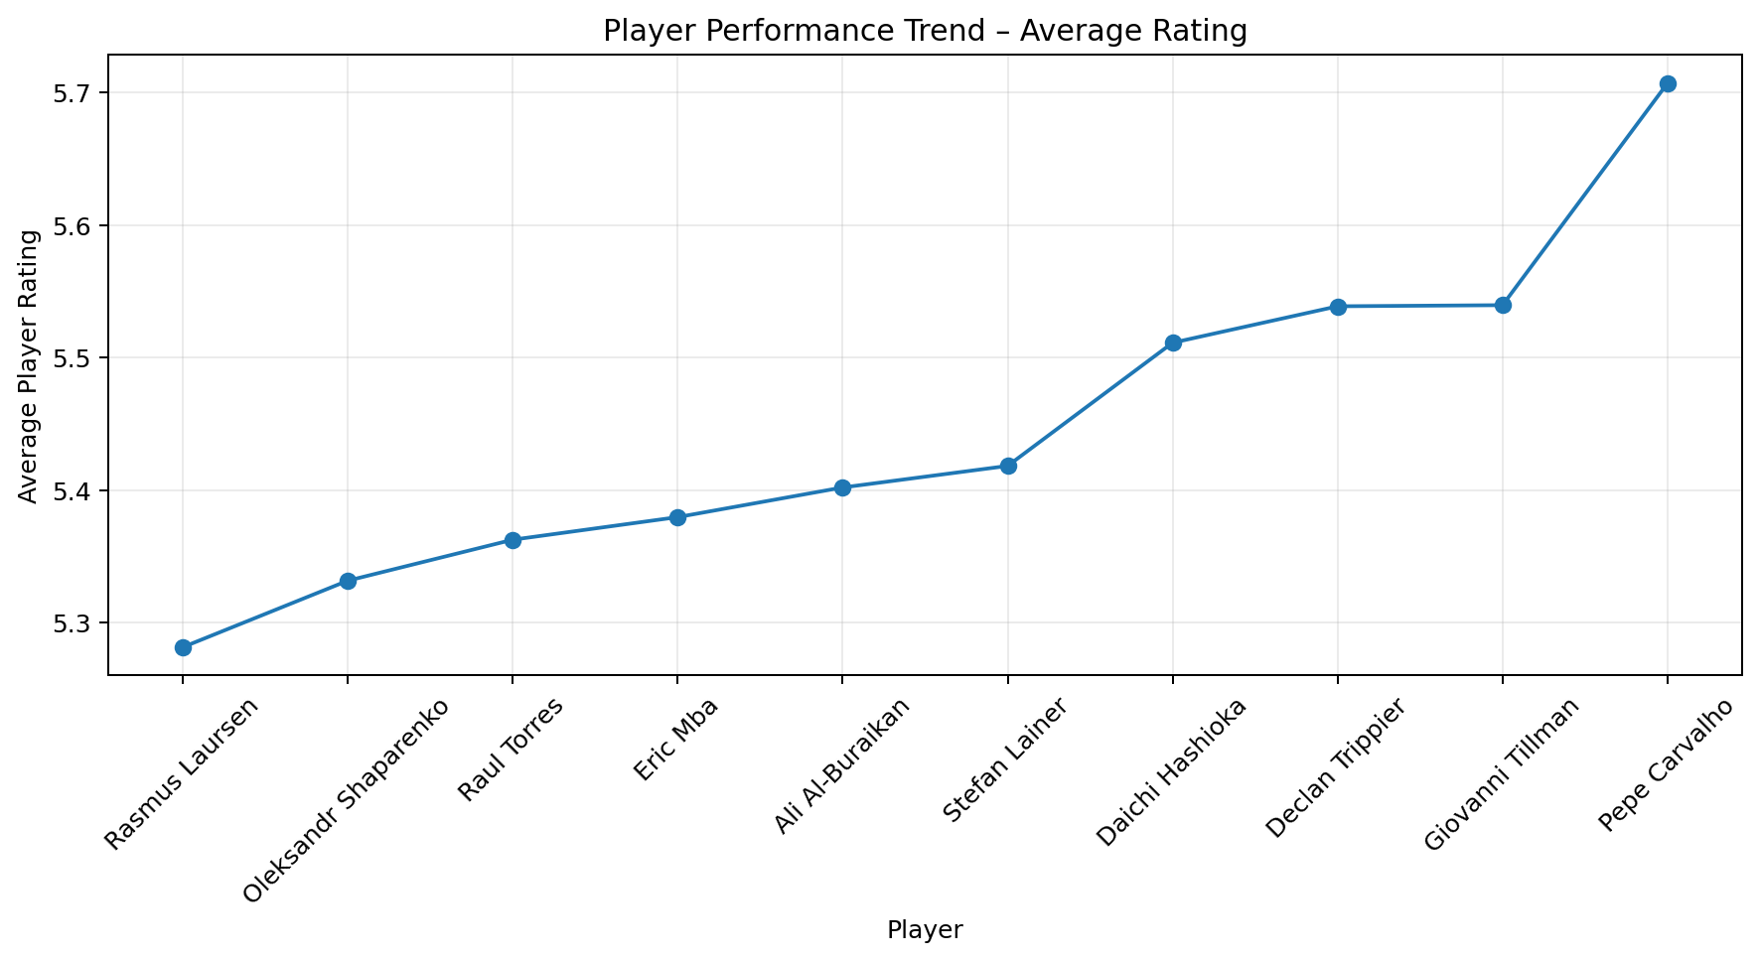
Step 5: Performance Percentage
- Create a calculated field named Performance Percentage.
- Use performance_score as the performance percentage when the score is measured on a 0–100 scale.
- Display player_name and AVG(performance_score).
Output: Performance Percentage
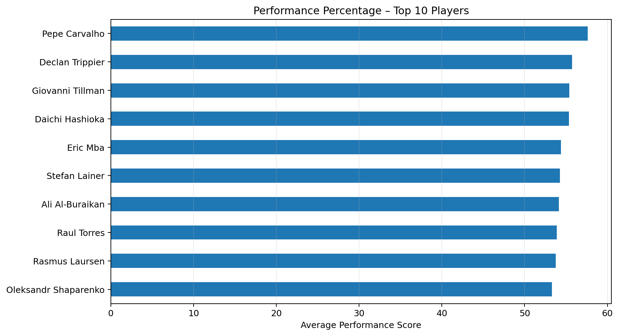
Step 6: Team Filter
- Add team to the Filters shelf.
- Select any available team.
- Observe the changes in the player goals, ratings, and performance visualizations.
Step 7: Minimum Performance Score Parameter
- Create a parameter named Minimum Performance Score.
- Set the parameter value to 70 for this output.
- Create a calculated field using the condition performance_score >= Minimum Performance Score.
- Apply the calculated field as a filter.
Output: Minimum Performance Score Parameter
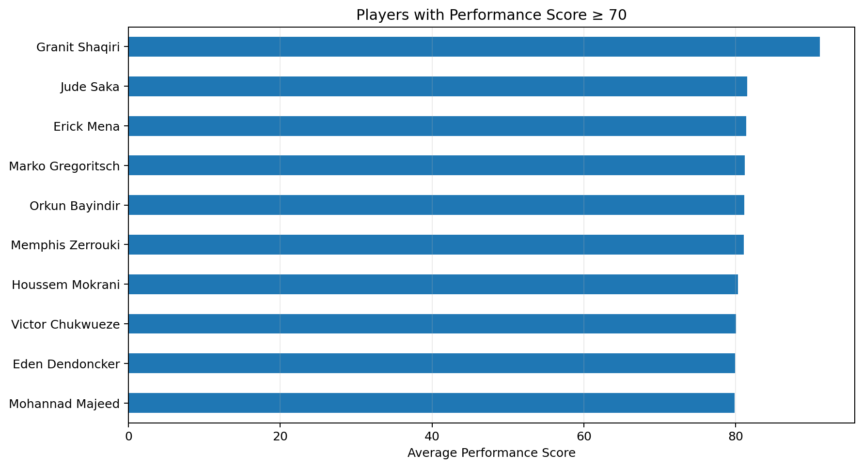
Step 8: Dashboard Creation
- Create a new Tableau Dashboard.
- Add the Player Goals, Team Goal Contribution, Player Performance Trend, Performance Percentage, and Minimum Performance Score worksheets.
- Add the Team filter and Minimum Performance Score parameter.
- Arrange the worksheets and format the titles, labels, legends, and tooltips.
Step 9: Story Creation
- Create a Tableau Story using the completed dashboard.
- Add story points for Overall Player Performance, Team-wise Goal Contribution, Top Goal Scorers, Player Rating Analysis, and Final FIFA Performance Analysis.
Step 10: Analysis
- Identify players with the highest goal contributions.
- Compare total goals among teams.
- Analyze average player ratings.
- Observe how the Team filter and Minimum Performance Score parameter change the visualizations.
- Use the dashboard and story to summarize overall player performance.
Output:
The output consists of player goals, team goal contribution, player rating trend, performance percentage, team filtering, and minimum performance score visualizations based on the FIFA World Cup 2026 Player Performance dataset.
Result:
Thus, the FIFA World Cup 2026 Player Performance dataset was analyzed successfully using Tableau-style visualizations. Charts, filters, a performance parameter, and dashboard components were prepared to study player and team performance.

